Featured Projects

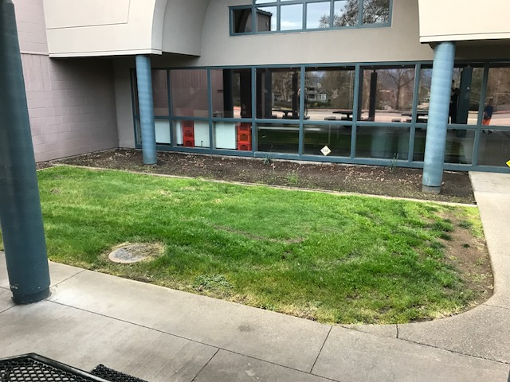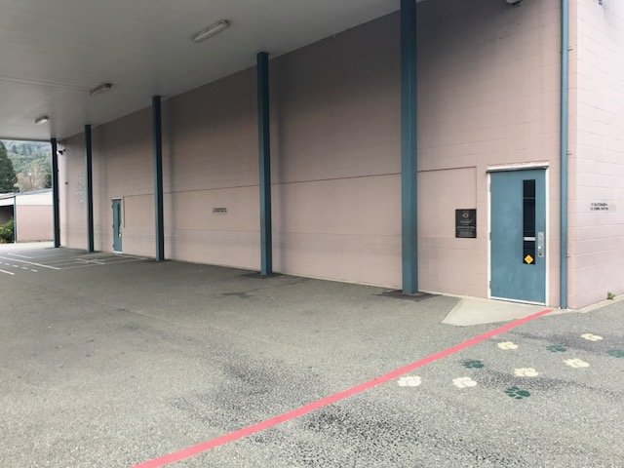

* Clean, paint and place Lincoln Lion Mascot * Remove grass and replace with artificial turf on outdoor wall under the cover. so students can sit on the “grass” during
lunch on nice days.
* Power was under cover
* Install planter beds where a vegetable/herb garden can be planted
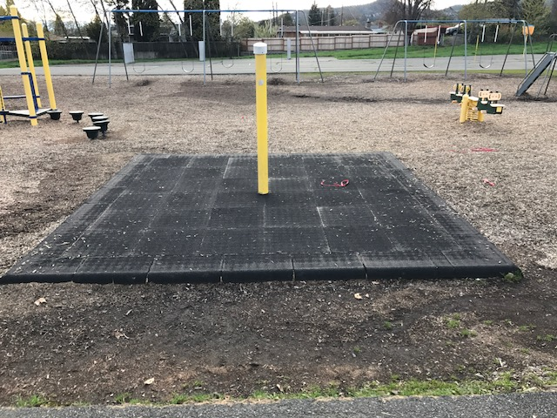
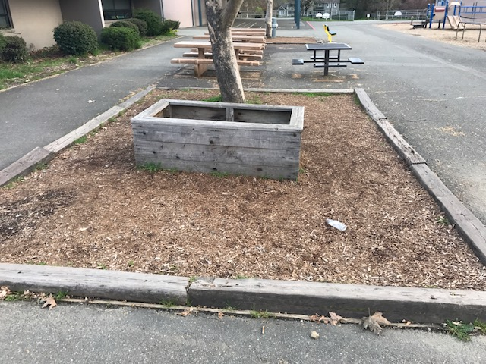

* Install new equipment in this area * Clean up and re-design beds
to make it usable and fun!

* Add fresh bark in the playground area. * Create new play area

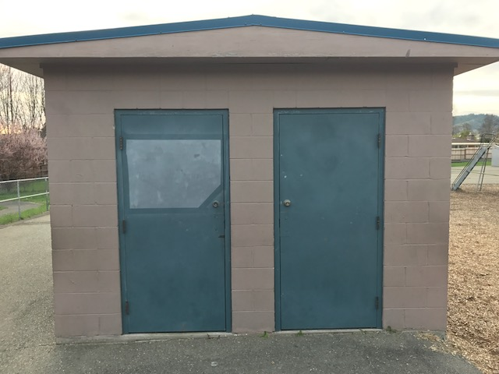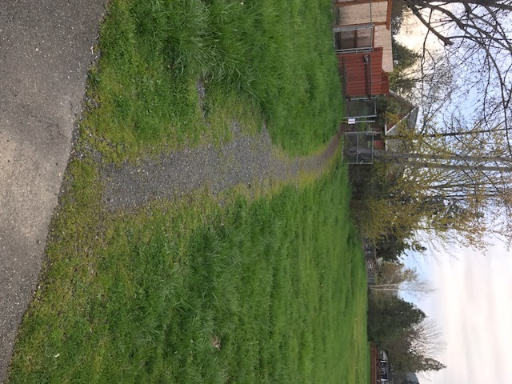

* Paint building/doors and place inspiring quotes. * Make pathway more useable.
* Fix broken fence/gate
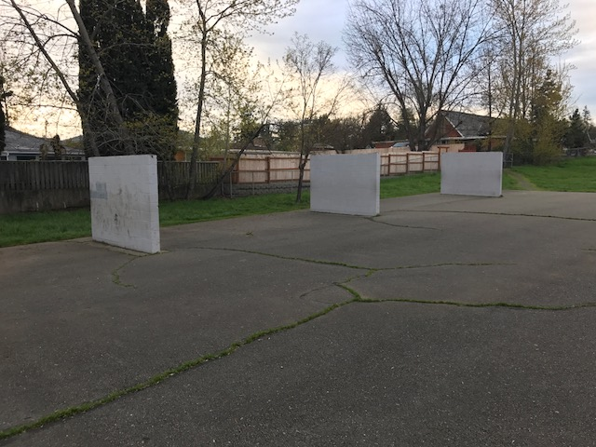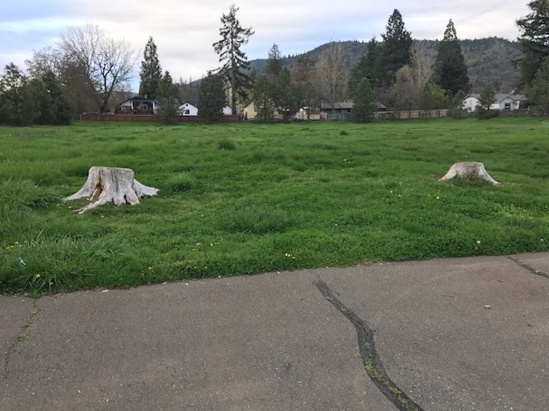

* Paint walls * Clean up and remove stumps
* Fill Cracks * Create sitting area
* Paint new blacktop activities

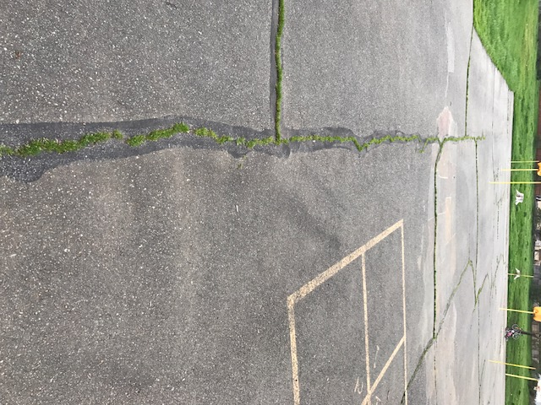
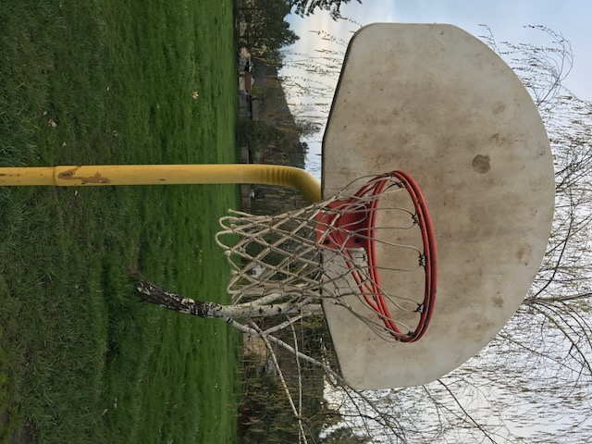

* Sandblast and powder coat hoops * Fill cracks
* Replace rims & nets * Repaint game lines
* Paint poles

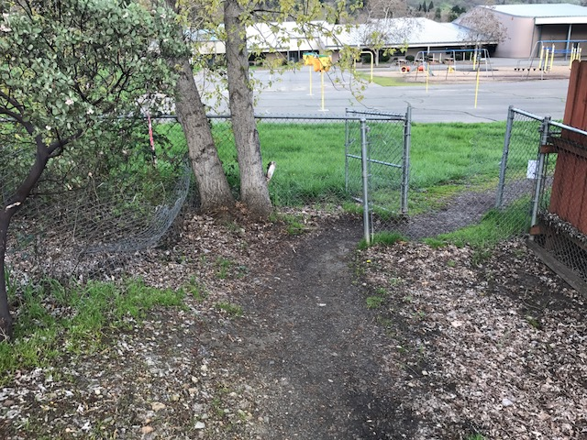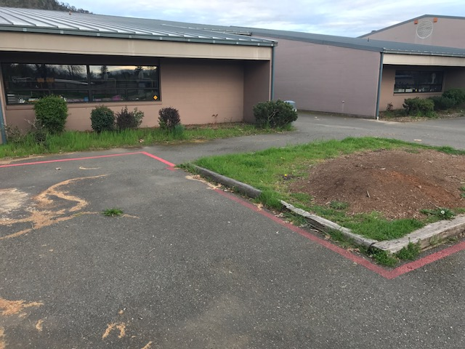

* Clean up pathway * Clean flowerbeds
* Fix gate * Add Fresh Bark

